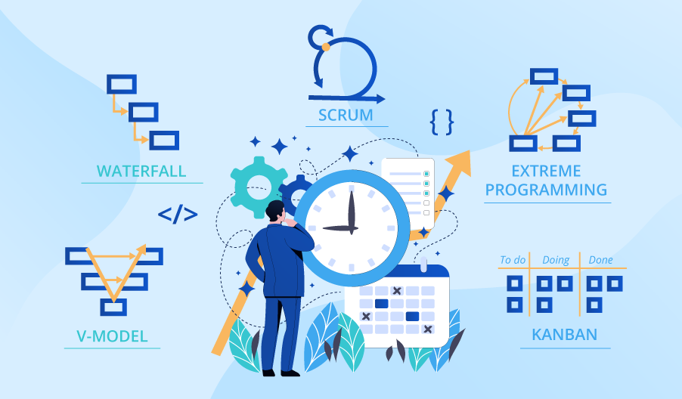

**SE423**

**Software Project Management**

**Assignment**

**Assignment 1.**

Answer the following questions:

1. Why do you believe PMI moved from knowledge areas and processes into principles and performance domains?
2. One of the new principles is “Embrace Adaptability and Resiliency”. How important is this principles in this changing world?

Submit your answers to LMS as PDF file.